Family members (vocabulary)
Συμπληρώστε τα κενά με τις παρακάτω λέξεις σύμφωνα με την εικόνα :
mother, father, sister, brother, husband, wife, son daughter
Tom Anna
↓ ↓
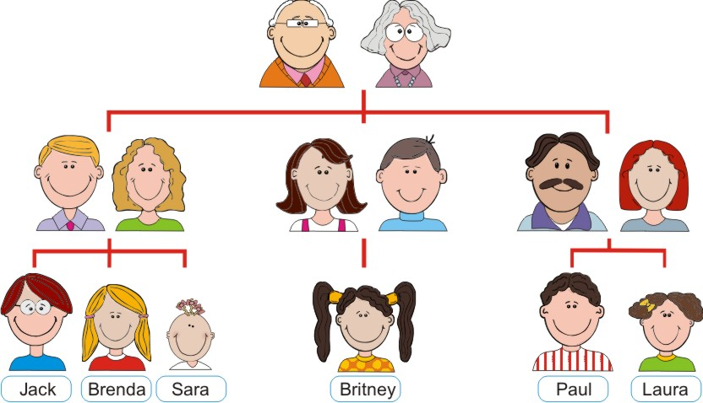
Roger Maria Fiona
- Maria is Roger’s __________________
- Tom is Fiona’s ____________________
- Anna is Maria’s ____________________
- Tom is Anna’s______________________
- Roger is Anna’s_____________________
- Maria is Tom’s ______________________
- Roger is Fiona’s _____________________
- Anna is Tom’s _______________________

